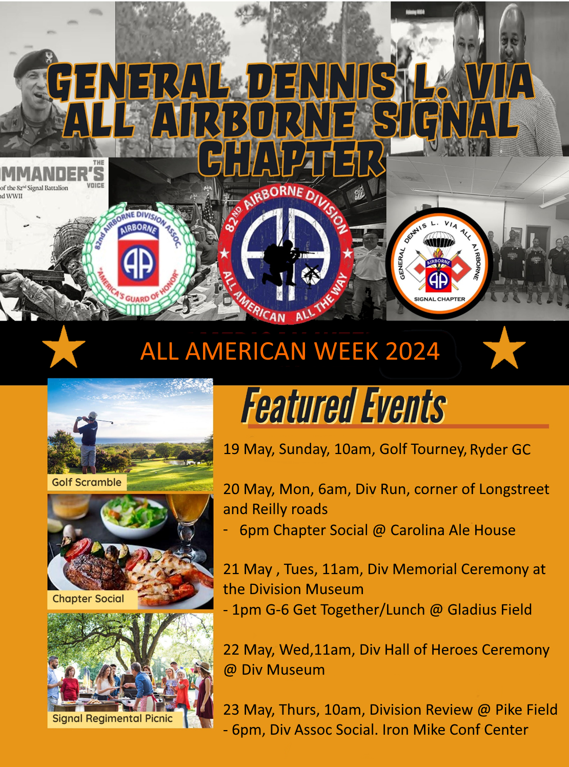
All American Week, list of major events, 19-23 May 2024
Date/Time: Event: Location: POC:

Sunday
19 May/1000 Sunday Round of Golf Ryder Golf Course Rock Schmidt
Monday
20 May/0600 Monday Div Run Corner of Reilly and Longstreet Terri Bishop
20 May/0900 Old Timers Breakfast BDE DFAC TBD
20 May/1800 Chapter Social Carolina Ale House Terri Bishop
20 May/1900 Memorabilia Sales Carolina Ale House Pete Hill
Tuesday
21 May/1100 Div Memorial Ceremony 5108 Ardennes Div Museum
21 May/1300 G-6 Get Together/ Regt Picnic Gladius Field, near DIV HQ Div G-6 Team
Wednesday
22 May/1100 Div HOH Ceremony 5108 Ardennes Div Museum
22 May/1100 Museum Certificate and Coins Museum or Monn Hall Moon Mulllins
Thursday
23 May/1000 Division Review Pike Field Terri Bishop/Pete Hill
Optional Event
23 May/1800 Div Assoc Social Iron Mike Conf Center

Coordinating Instructions: If you are planning to attend, we ask you to notify one of the Chapter EXCOMs directly or email the Vice-Chairman at timwallallabnsigchapter@gmail.com. As with any operation, we will set up comms for the week with known attendees, so that if anyone needs anything, we can try to provide that support
We deliberately planned Chapter events around Association and Division sponsored events so those who are interested may attend those events. We also purposely left a lot of free time as we know LGOPs will do what LGOPs do and want to plan their own events and reunions with fellow Paratroopers. If you have any questions, please feel free to contact Tim Wall at the email address provided above.
The Hospitality Suite. Almost every year we have setup, stocked, and ran a hospitality suite for AA Week. It is a great chance to mingle with your separate groups and see other people from the Signal Chapter or Signal Alumni in a social setting. Here are some details. We will open this up Sunday, Tuesday and Wednesday Evenings. We normally have free beer, wine, and finger food to consume onsite while hanging out with us. Bear in mid we will also have our memorabilia on display for those interested in purchasing cool gear.
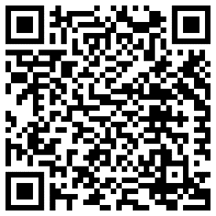
Lodging:
- The Chapter host hotel is the Embassy Suites by Hilton located at 4760 Lake Valley Drive in Fayetteville. You are not required to stay at this hotel, but we have a block of rooms at a group rate. Book your Signal Chapter group rate here. Approx $189. Top QR Code
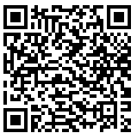
- Also, rooms available at Residence Inn Fayetteville Cross Creek for 139 USD - 179 USD per night, Book your group rate for Signal Chapter of the 82nd ABN DIV Assoc. - All American Week. Bottom QR Code.
Airborne. All the Way!
Tim Wall, Chapter Vice-Chairman, and Rock Schmidt, Chapter Chairman

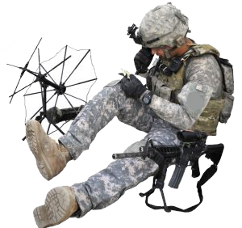
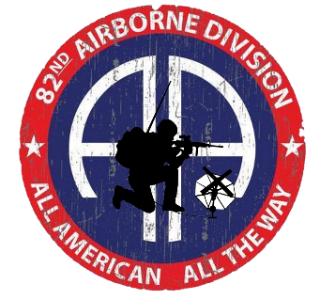
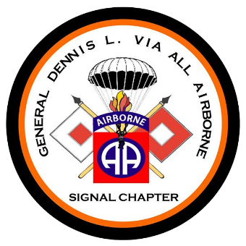
All American Week 2024—Signal Golf Scramble
19 May, 1000am – Ryder Golf Course Fort Liberty, N.C.
Point of contact for The Signal Chapter Team—COL(R) Rock Schmidt
Point of contact for Division G-6 Team, SGM AC
Course additional Info available here, https://bragg.armymwr.com/programs/fort-bragg-golf

