Celebration of signal Valor. Staff Sergeant Penderman of the 2nd BCT, battlefield promotion During the Battle of Mosul
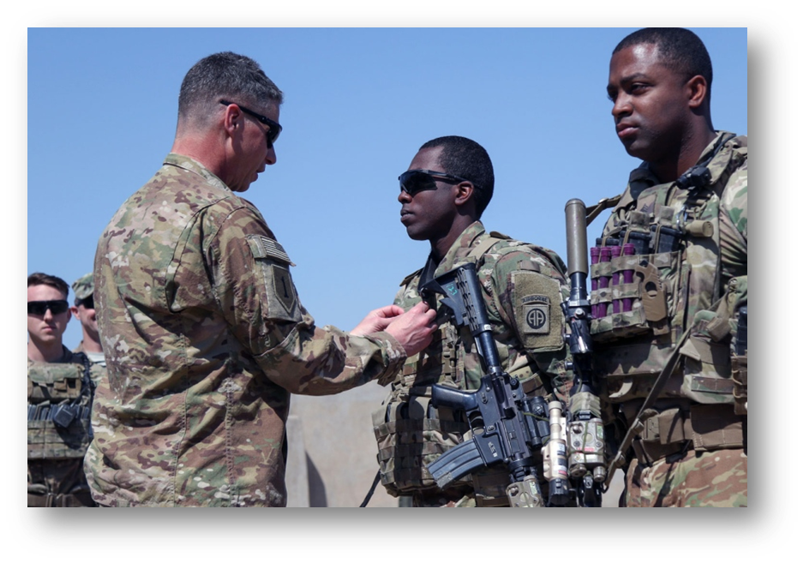
Task Force Falcon, 2nd Brigade Combat Team, 82nd Airborne Division, Operation Inherent Resolve (OIR) 2017 ,
U.S. Army Maj. Gen. Joseph M. Martin, pins a battlefield promotion onto Staff Sgt. Jeremy R. Penderman, assigned to the 2nd Brigade Combat Team, 82nd Airborne Division, near Al Tarab, Iraq, March 30, 2017.

A Note on Legacy, Loss, and Celebration
Our documented historical series on the Global War on Terrorism has often focused on the profound loss suffered by the 82nd Airborne Division’s formations, upholding the solemn commitment to remember the soldiers we lost in combat. This article shifts focus to a rare and powerful moment of combat distinction—a Battlefield Promotion (BFP). It is a story of conspicuous leadership and success under fire, a testament to the enduring excellence of the Division’s Non-Commissioned Officer (NCO) corps. Even after the inactivation of the 82nd Signal Battalion in 2006, its lineage of highly skilled technical specialists was re-aligned to serve within the Brigade Combat Teams, maintaining the Division's technical and tactical mastery on the forward edge. This successful action is a profound moment that must be celebrated.
Task Force Falcon Enters the Crucible
The deployment of the 2nd Brigade Combat Team (2nd BCT), 82nd Airborne Division—historically known as Task Force Falcon—in early 2017 placed its paratroopers directly into the crucible of the Global War on Terrorism. The unit arrived in theater during the decisive phase of the multi-month Battle of Mosul, specifically as the fight shifted to the intense, protracted urban warfare of West Mosul. The Brigade's deployment timeline, running from January through September 2017, overlapped precisely with the climactic operations against ISIS.
The 2nd BCT’s mission within Operation Inherent Resolve (OIR) was centered on the complex Advise and Assist (A&A) strategy. The 2nd BCT was commanded during this critical deployment by Colonel J. Patrick Work, who later served as the Commanding General of the 82nd Airborne Division from November 2023 to August 2025. Task Force Falcon was tasked with enabling the military defeat of ISIS by closely supporting local partners, primarily the 9th Iraqi Army Division. This role was distinct from major theater combat—it required small teams of highly competent U.S. personnel to be embedded in a close-support role, providing planning, intelligence collection and analysis, crucial force protection, and precision fires. This continuous operational commitment cemented the 2nd BCT’s role as a key maneuver element in the strategic efforts of the United States Army in the Middle East.
The Individual and the Tactical Environment at Al Tarab
The documented action involving Staff Sergeant Jeremy R. Penderman occurred during this critical deployment. The location of the confirmed action—the Battlefield Promotion—was near Al Tarab, Iraq, a forward patrol base that geographically and temporally sat at the heart of the campaign’s most intense fighting in March 2017. This was no hardened operating base—the designation of a "patrol base" near Al Tarab implies a tactical base of operations in proximity to, or only recently secured from, active fighting. The severity of the operational environment is evidenced by the fact that U.S. Army Sergeants and other Paratroopers of the 2nd BCT’s infantry regiments were operating from rooftop observation posts within Mosul itself during this period.
It was in this high-risk environment that Staff Sergeant Jeremy R. Penderman, a Paratrooper with the 2nd BCT, distinguished himself. As a Sergeant (E-5) in an A&A team, his role required independent decision-making and immediate leadership under hostile fire, often needing to assume greater independence and command authority than his assigned rank typically demanded. His successful execution of duties and demonstration of the technical proficiency required of a higher grade were so effective, so critical to the ongoing fight, that they transcended the typical administrative process. His performance, achieved under conditions of immediate threat near Al Tarab, confirmed he was already executing at the E-6 level successfully during the combat operations of the Battle of Mosul.
The Doctrine and Significance of the BFP
The core documented fact of this distinguished service is the Battlefield Promotion (BFP) of Jeremy R. Penderman from Sergeant (E-5) to the rank of Staff Sergeant (E-6) on March 30, 2017.
The BFP is among the rarest and most significant forms of military recognition. Doctrinally, it is a meritorious promotion that bypasses standard administrative requirements—time-in-service, time-in-grade, and institutional NCO education. The criteria are strictly limited to demonstration of extraordinary valor, exceptional performance of duties, and immediate leadership under hostile fire, resulting in a decisive tactical outcome. The BFP is thus not merely an administrative advancement, but a direct, instantaneous certification of higher authority and responsibility.
Crucially, the authority under which the promotion was granted elevates its distinction to an extraordinary level. The promotion was not administered by his Brigade Commander, but by U.S. Army Maj. Gen. Joseph M. Martin, who held the dual command positions of Commanding General for the Combined Joint Forces Land Component Command – Operation Inherent Resolve (CJFLCC-OIR) and the 1st Infantry Division.
A Two-Star General on the Frontline
The personal involvement of a two-star general commanding the entire ground component of the campaign, traveling to a forward patrol base near Al Tarab, provides powerful verification of the operational environment’s gravity and the importance of the action being recognized.
The command presence observed during the promotion underscores a profound command emphasis placed on this particular act of service. The high-level, on-the-spot ceremony certified that Sergeant Penderman's act of service was consequential enough to merit a direct validation from the highest echelon of the ground command structure. The immediate promotion confirmed that Penderman had successfully assumed and executed the necessary leadership role and technical proficiency required of a Staff Sergeant during the engagement, validating his pivotal contribution to the A&A mission’s success during the height of the Battle of Mosul. This synergy between the A&A mission structure and the BFP mechanism underscores the importance of individual NCO competence in determining overall mission success.
Legacy and Findings
Staff Sergeant Penderman’s achievement serves as the definitive and verifiable official military distinction stemming from his service during the Global War on Terrorism. The mechanism of the BFP certifies a contribution involving immediate leadership, valor, and successful execution of critical duties under hostile fire. This recognition validates the essential and enduring role of the Non-Commissioned Officer Corps—including all re-aligned signal and technical specialists—in the success of the A&A strategy in 2017. His rapid, combat-justified advancement confirms his pivotal contribution to the campaign to defeat ISIS during the height of the Battle of Mosul, standing as a clear reason to celebrate the courage and skill of the Paratroopers of the 2nd BCT.

This article on SSG Penderman was put together referencing this us army article published in 2017, https://www.army.mil/article/188528/maj_gen_martin_visits_2nd_brigade_82nd_airborne_patrol_base_in_iraq
Notes on the pic, U.S. Army Maj. Gen. Joseph M. Martin, pins a battlefield promotion onto Staff Sgt. Jeremy R. Penderman, assigned to the 2nd Brigade Combat Team, 82nd Airborne Division, near Al Tarab, Iraq, March 30, 2017.

